Student Report System – User Guide

1. Overview

The Student Report System is a console application. Interactions with the program are via a menu system and simple commands. Messages generated by the application also appear in the same console.

This application requires a text file to be copied to your file system. The file is called “studentdata.txt” and needs to be located in the directory “C:/Temp”.

The application reads the text file. Extracting the following student information:

* Student first name
* Student last name
* Student Math marks for assignment 1 to 3
* Student English marks for assignment 1 to 3

Each student also has a Student ID. Which is unique and is a whole number from 0 to 100000. This Student ID ensures there are no duplicates in the database and allows students to be removed and added to a student database.

Student information can only be read from the text file. Students can not be added or removed from the text file.

The application then presents a menu. Each item on the menu is accessed by entering a number corresponding to the required action.

The application can carry out four actions:

* + 1. Displays all the students in the database along with their marks, including their average mark, for each course
    2. Display all the students in the database along with their grades, including their average grade, for each course
    3. Add a new student to the database. The user is prompted for the required student data
    4. Remove a student from the database. The user is prompted for the student’s ID

1. Menu

The menu system looks like…

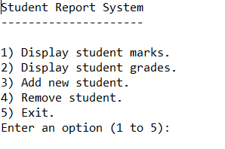

Enter 1 to get a report of student marks…

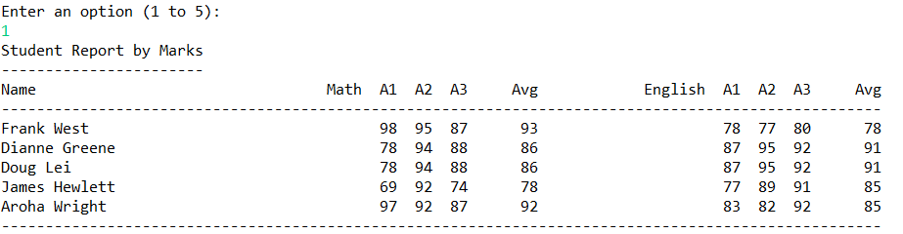

Enter 2 to get a report of student grades…

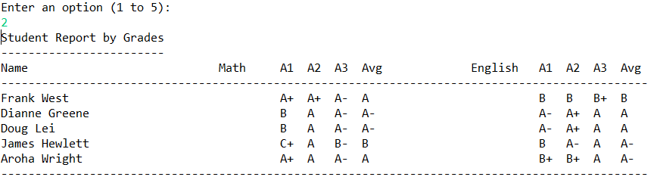

Enter a 3 to add a new student. Answer the prompts as follows…

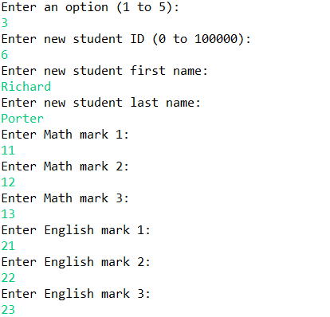

Enter a 4 to remove a student. Enter the student ID as follows…

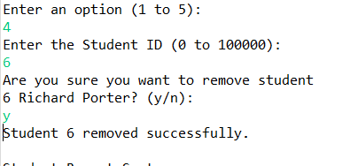

To exit the application enter 5…

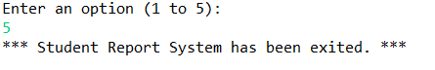

1. Messages

The application checks for appropriate user responses. If an inappropriate response is detected the following messages will be displayed…

1. Entering an inappropriate option. User will be requested to enter an appropriate option…



1. Entering a letter instead of a number…

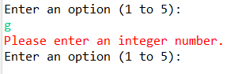

1. Entering a student ID outside of the required range. User will be prompted for an appropriate student ID…

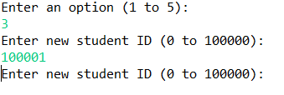

1. Entering a character or entering an ID that already exists in the database…

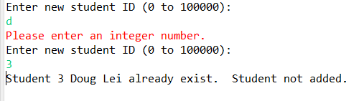

1. Trying to remove a student not in the database…

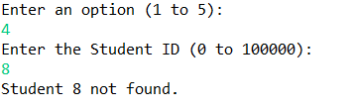

---oOo---